**UNIVERSITY OF KARACHI**



**Probability and Statistical Methods**

BSCS-306

**Name of Student: MUHAMMAD AMAS**

**Seat No: B20102077**

**Class Roll No: 36**

**Section: A**

**Semester No: 2nd**

**Submitted to: Dr. Tahseen A. Jilani**

**DEPARTMENT OF COMPUTER SCIENCE**

UNIVERSITY OF KARACHI

When you click the **Knit** button a document will be generated that includes both content as well as the output of any embedded R code chunks within the document. You can embed an R code chunk like this

## Input data into R

library(datasets)  
###Following Data Set is about the weight of Chickens on different diets.  
  
#if you wanna see data set so remove '#' from the bottom line  
#data(ChickWeight)  
View(ChickWeight)  
  
#Showing upper few values of Data Set  
head(ChickWeight)

## weight Time Chick Diet  
## 1 42 0 1 1  
## 2 51 2 1 1  
## 3 59 4 1 1  
## 4 64 6 1 1  
## 5 76 8 1 1  
## 6 93 10 1 1

#Showing Last few values of Data Set  
tail(ChickWeight)

## weight Time Chick Diet  
## 573 155 12 50 4  
## 574 175 14 50 4  
## 575 205 16 50 4  
## 576 234 18 50 4  
## 577 264 20 50 4  
## 578 264 21 50 4

## Data Summaries/ Description

#Will show the names of the columns  
names(ChickWeight)

## [1] "weight" "Time" "Chick" "Diet"

# Dimension of data set.  
dim(ChickWeight)

## [1] 578 4

# Giving a summarized view of data set.  
summary(ChickWeight)

## weight Time Chick Diet   
## Min. : 35.0 Min. : 0.00 13 : 12 1:220   
## 1st Qu.: 63.0 1st Qu.: 4.00 9 : 12 2:120   
## Median :103.0 Median :10.00 20 : 12 3:120   
## Mean :121.8 Mean :10.72 10 : 12 4:118   
## 3rd Qu.:163.8 3rd Qu.:16.00 17 : 12   
## Max. :373.0 Max. :21.00 19 : 12   
## (Other):506

# Describing one quantitative variable.  
library(psych)

describe(ChickWeight)

## vars n mean sd median trimmed mad min max range skew kurtosis  
## weight 1 578 121.82 71.07 103 113.18 69.68 35 373 338 0.96 0.34  
## Time 2 578 10.72 6.76 10 10.77 8.90 0 21 21 -0.02 -1.26  
## Chick* 3 578 26.26 14.00 26 26.27 17.79 1 50 49 0.00 -1.19  
## Diet* 4 578 2.24 1.16 2 2.17 1.48 1 4 3 0.31 -1.39  
## se  
## weight 2.96  
## Time 0.28  
## Chick* 0.58  
## Diet* 0.05

## Data Plots/ Visualization

plot(ChickWeight$weight, ChickWeight$Diet, col="#940034")

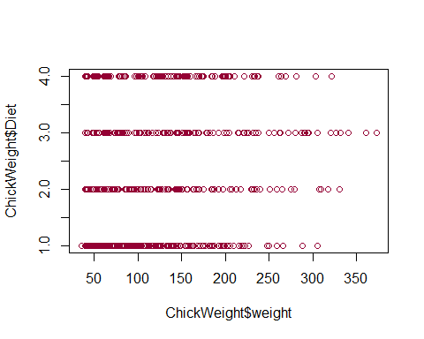

#it shows Scattered Plot of Chick weight with Chick diet

boxplot(ChickWeight$weight ~ ChickWeight$Diet, main="Weight Box Plot According to Different Diets", col = "thistle1")

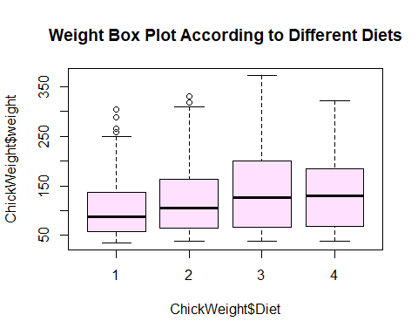

#Plot shows that chicks are gaining weight on Diet number 3

##Histograms of Chick Weights according to their Diets.  
hist(ChickWeight$weight [ChickWeight$Diet =="1"],  
 col = "#ffd966",   
 xlim = c(0,200),  
 breaks = 15,  
 main = "Histogram: Weight on Diet 1",  
 xlab = "Weight (in kg)")

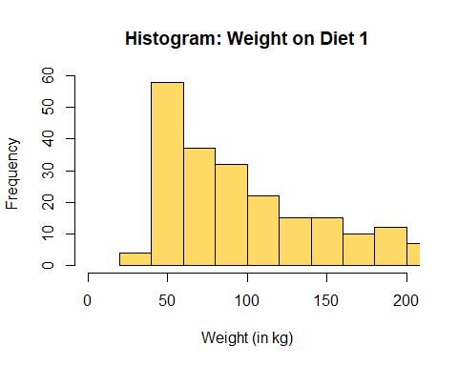

hist(ChickWeight$weight [ChickWeight$Diet =="2"],  
 col = "#ffd966",   
 xlim = c(0,200),  
 breaks = 15,  
 main = "Histogram: Weight on Diet 2",  
 xlab = "Weight (in kg)")

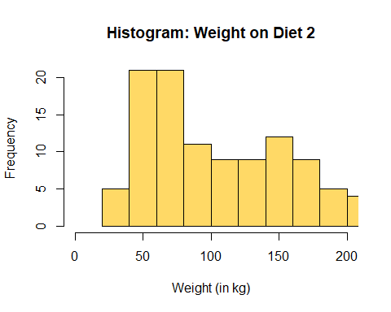

hist(ChickWeight$weight [ChickWeight$Diet =="3"],  
 col = "#ffd966",   
 xlim = c(0,200),  
 breaks = 15,  
 main = "Histogram: Weight on Diet 3",  
 xlab = "Weight (in kg)")

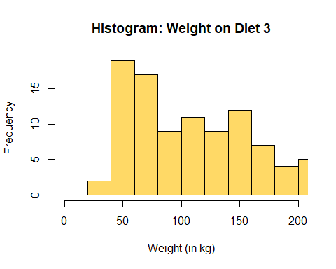

hist(ChickWeight$weight [ChickWeight$Diet =="2"],  
 col = "#ffd966",   
 xlim = c(0,200),  
 breaks = 15,  
 main = "Histogram: Weight on Diet 4",  
 xlab = "Weight (in kg)")

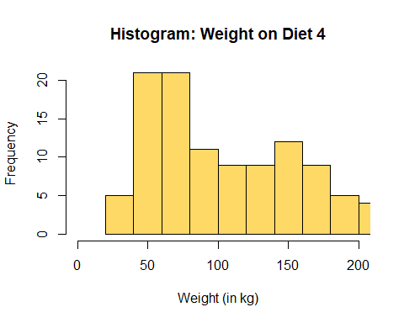

Weight_of_chicks <- table(ChickWeight$weight)  
  
#Bar plot of Chick Weights  
barplot(Weight_of_chicks,  
 main = "Bar chart: of chick weights",  
 col = "#134f5c",  
 xlab = "Weights",  
 ylab = "Frequency")

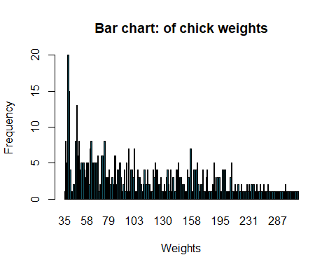

#Line Charts of Chick Weights  
plot(Weight_of_chicks,  
 main = "Line chart: of chick weights",  
 col = "#134f5c",  
 xlab = "Weights",  
 ylab = "Frequency")

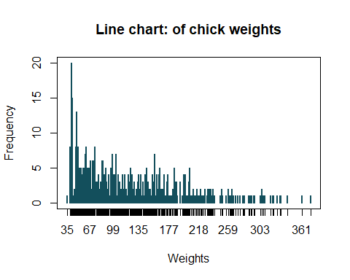

## Correlation

library(corrplot)

## corrplot 0.92 loaded

cor(ChickWeight[, unlist(lapply(ChickWeight, is.numeric))])

## weight Time  
## weight 1.0000000 0.8371017  
## Time 0.8371017 1.0000000

cor.mat.ChickWeight = cor(ChickWeight[, unlist(lapply(ChickWeight, is.numeric))])  
corrplot(cor.mat.ChickWeight)

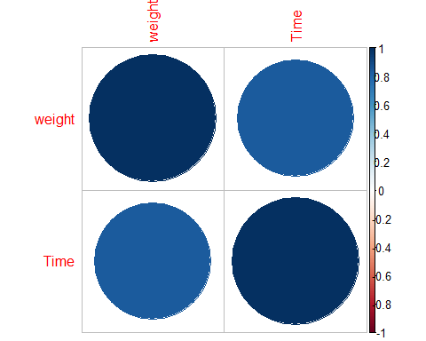

#From the plots we have concluded that the correlation is strong Positive.

## 

## Confidence Interval

library(Rmisc)

CI(ChickWeight$weight, ci = 0.95)

## upper mean lower   
## 127.6246 121.8183 116.0121

#Hence mean is lying in the confidence interval so we will accept the Null hypothesis.  
  
CI(ChickWeight$Time, ci = 0.95)

## upper mean lower   
## 11.27012 10.71799 10.16586

#Hence mean is lying in the confidence interval so we will accept the Null hypothesis.

## Hypothesis Testing

library(stats)  
  
#one sample t test  
#Question: Is the mean value of Weights from 121.8 or not?  
t.test(ChickWeight$weight, mu=121.8)

##   
## One Sample t-test  
##   
## data: ChickWeight$weight  
## t = 0.0062036, df = 577, p-value = 0.9951  
## alternative hypothesis: true mean is not equal to 121.8  
## 95 percent confidence interval:  
## 116.0121 127.6246  
## sample estimates:  
## mean of x   
## 121.8183

#answer:First this is two tail test after this the mean value of weights differs from 121.8,and p value is more than 0.05 so null hypothesis is accepted  
  
#Is the mean value of Murder differ from 10.72 or not?  
t.test(ChickWeight$Time, mu=10.72)

##   
## One Sample t-test  
##   
## data: ChickWeight$Time  
## t = -0.0071392, df = 577, p-value = 0.9943  
## alternative hypothesis: true mean is not equal to 10.72  
## 95 percent confidence interval:  
## 10.16586 11.27012  
## sample estimates:  
## mean of x   
## 10.71799

#answer:Two tail test after this the mean value of time differs from 10.72,and p value is more than 0.05 so null hypothesis is accepted  
  
#Two Sample Test  
x <- rnorm(ChickWeight$weight)  
y <- rnorm(ChickWeight$Diet)  
t.test(x,y, var.equal = TRUE)

##   
## Two Sample t-test  
##   
## data: x and y  
## t = -0.41859, df = 1154, p-value = 0.6756  
## alternative hypothesis: true difference in means is not equal to 0  
## 95 percent confidence interval:  
## -0.13766757 0.08925494  
## sample estimates:  
## mean of x mean of y   
## -0.04587380 -0.02166748

#True difference in means is not equal to 0

## Chi Square Test

#apply the Chi-Square test to see test of association/ independence.  
chisq.test(ChickWeight$weight, ChickWeight$Diet)

## Warning in chisq.test(ChickWeight$weight, ChickWeight$Diet): Chi-squared  
## approximation may be incorrect

##   
## Pearson's Chi-squared test  
##   
## data: ChickWeight$weight and ChickWeight$Diet  
## X-squared = 631.55, df = 633, p-value = 0.5088

#we have x-squared = 631.55,Since we get a p-Value greater than the significance level of 0.05, we accept the null hypothesis and conclude that the two variables are in fact independent.

## Analysis of Variance

#Question: Does the diet effect on weights?  
  
boxplot(ChickWeight$weight ~ ChickWeight$Diet, col= "#ffc9c9")

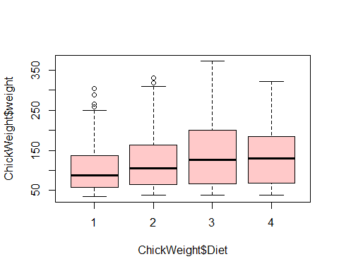

model1 <- aov(ChickWeight$weight ~ ChickWeight$Diet)  
summary(model1)

## Df Sum Sq Mean Sq F value Pr(>F)   
## ChickWeight$Diet 3 155863 51954 10.81 6.43e-07 ***  
## Residuals 574 2758693 4806   
## ---  
## Signif. codes: 0 '***' 0.001 '**' 0.01 '*' 0.05 '.' 0.1 ' ' 1

#it is observed that the F-statistic value is 10.81 and it is significant as the corresponding p-value is smaller. Thus, it is wise to reject the null hypothesis of diets. In other words, the weights in diets does affect.  
  
library(gplots)

## Attaching package: 'gplots'

## The following object is masked from 'package:stats':  
##   
## lowess

plotmeans(ChickWeight$weight ~ ChickWeight$Diet, main="Mean Plot with 95% Confidence Interval", ylab = "Diet", xlab = "Weight", col = "#ffa09f")

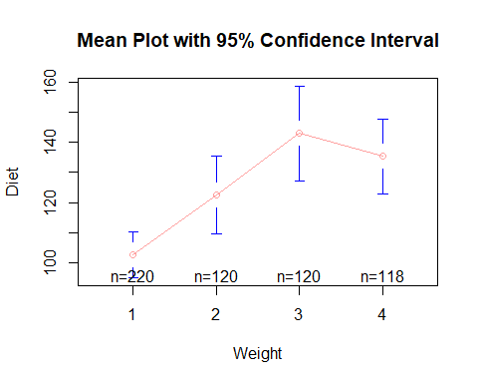

## Linear and Multiple Regression Models

###Linear Regression line formula:  
  
# This will give details of the model including the   
# correlation, parameters (intercept and slope) along with P-value and Mean sum of squares.  
  
attach(ChickWeight)  
  
fit.LR <- lm(weight~ Diet, data = ChickWeight)  
summary(fit.LR)

##   
## Call:  
## lm(formula = weight ~ Diet, data = ChickWeight)  
##   
## Residuals:  
## Min 1Q Median 3Q Max   
## -103.95 -53.65 -13.64 40.38 230.05   
##   
## Coefficients:  
## Estimate Std. Error t value Pr(>|t|)   
## (Intercept) 102.645 4.674 21.961 < 2e-16 ***  
## Diet2 19.971 7.867 2.538 0.0114 *   
## Diet3 40.305 7.867 5.123 4.11e-07 ***  
## Diet4 32.617 7.910 4.123 4.29e-05 ***  
## ---  
## Signif. codes: 0 '***' 0.001 '**' 0.01 '*' 0.05 '.' 0.1 ' ' 1  
##   
## Residual standard error: 69.33 on 574 degrees of freedom  
## Multiple R-squared: 0.05348, Adjusted R-squared: 0.04853   
## F-statistic: 10.81 on 3 and 574 DF, p-value: 6.433e-07

#ANSWER:firstly,P value is less than 0.05 which mean intercept is significant while in Diets we see that p value is less than 0.05 so it will be accepted so in other word we can say that Diet has much significance impact on the Weight. Secondly, signs are positive which shows if one increases other greatly increases as well ,In Multiple R-squared is 0.04853 so for correlation we do square root of it so answer is 0.2202 which is positive so there is some corelation with Weight and Diet.  
  
###PLOTS:  
scatter.smooth(x=Diet, y = weight, main="weight ~ Diet")

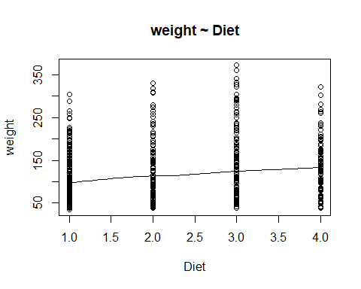

library(ggplot2)

##   
## Attaching package: 'ggplot2'

## The following objects are masked from 'package:psych':  
##   
## %+%, alpha

ggplot(ChickWeight,aes(y=Time,x=weight))+geom_point()+geom_smooth(method="lm")

## `geom_smooth()` using formula 'y ~ x'

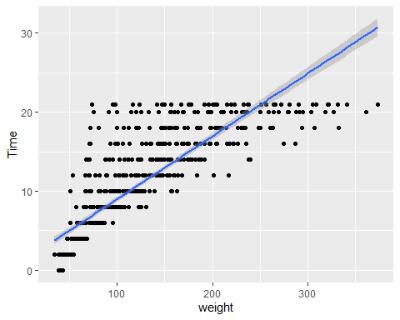

#plots show us:  
#1)Linearity  
  
#The relationship between the independent and dependent variable must be linear. We can test this visually with a scatter plot to see if the distribution of data points could be described with a straight line.  
  
#2)Independence of observations  
  
#Because we only have one independent variable and one dependent variable from the given data result so, we don’t need to test for any hidden relationships among variables.  
  
#3)Normality  
  
#using the hist function we find from the above data the whether dependent variable follows normal distribution  
  
###Multiple Regression line formula:  
#---------------------------------  
  
fit.MR <- lm(weight~ + Time + Diet , data = ChickWeight)  
summary(fit.MR)

##   
## Call:  
## lm(formula = weight ~ +Time + Diet, data = ChickWeight)  
##   
## Residuals:  
## Min 1Q Median 3Q Max   
## -136.851 -17.151 -2.595 15.033 141.816   
##   
## Coefficients:  
## Estimate Std. Error t value Pr(>|t|)   
## (Intercept) 10.9244 3.3607 3.251 0.00122 **   
## Time 8.7505 0.2218 39.451 < 2e-16 ***  
## Diet2 16.1661 4.0858 3.957 8.56e-05 ***  
## Diet3 36.4994 4.0858 8.933 < 2e-16 ***  
## Diet4 30.2335 4.1075 7.361 6.39e-13 ***  
## ---  
## Signif. codes: 0 '***' 0.001 '**' 0.01 '*' 0.05 '.' 0.1 ' ' 1  
##   
## Residual standard error: 35.99 on 573 degrees of freedom  
## Multiple R-squared: 0.7453, Adjusted R-squared: 0.7435   
## F-statistic: 419.2 on 4 and 573 DF, p-value: < 2.2e-16

#answer:P value is very low in intercept and in murder it has +ve sign so positive correlation exists in it and taking sq.rt of Multiple R-squared: 0.7453 we get 0.694.  
  
# beta0 = intercept of the regression line. which is 27.8983  
# beta1 = slope of the time is 8.7152  
# beta1 = slope of the Diet 2 is 16.1661  
# beta1 = slope of the Diet 3 is 36.4994  
# beta2 = slope of the Diet 4 is 30.2335  
  
library(dplyr)

## Warning: package 'dplyr' was built under R version 4.1.2

##   
## Attaching package: 'dplyr'

## The following objects are masked from 'package:plyr':  
##   
## arrange, count, desc, failwith, id, mutate, rename, summarise,  
## summarize

## The following objects are masked from 'package:stats':  
##   
## filter, lag

## The following objects are masked from 'package:base':  
##   
## intersect, setdiff, setequal, union

library(ggplot2)  
  
ChickWeight %>%  
 filter(weight < 373)%>%  
 ggplot(aes(x=weight, y=Diet , col = weight))+ geom_point(alpha = 1)+  
 geom_smooth(method = lm)

## `geom_smooth()` using formula 'y ~ x'

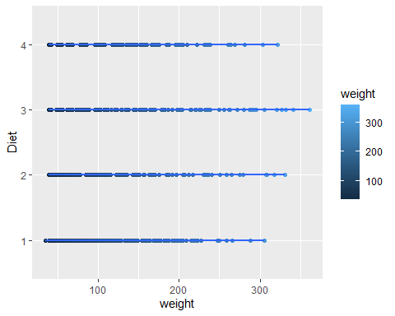

ChickWeight %>%  
 filter(weight < 373)%>%  
 ggplot(aes(x=weight, y=Time , col = weight))+ geom_point(alpha = 1)+  
 geom_smooth(method = lm)

## `geom_smooth()` using formula 'y ~ x'

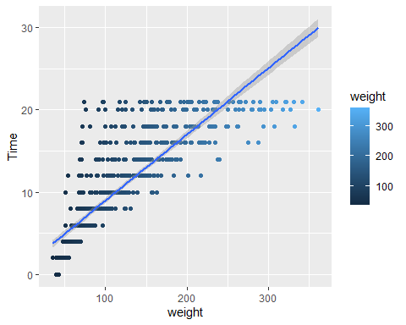

# Q:Is the overall regression model suitable?  
# ---------------------------------------  
anova(fit.LR) # Test difference in slopes (joint F-test)

## Analysis of Variance Table  
##   
## Response: weight  
## Df Sum Sq Mean Sq F value Pr(>F)   
## Diet 3 155863 51954 10.81 6.433e-07 ***  
## Residuals 574 2758693 4806   
## ---  
## Signif. codes: 0 '***' 0.001 '**' 0.01 '*' 0.05 '.' 0.1 ' ' 1

# The F-statistic value will tell whether the result is good or not.  
  
#answer: the f statistic value is 10.81 and P value is less than 0.05 so we can say that by judging by f value result is good.

## 

## T-test formula for Intercept

## 

## T-test formula for Slope

